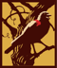

2018 Chardonnay
Trinity

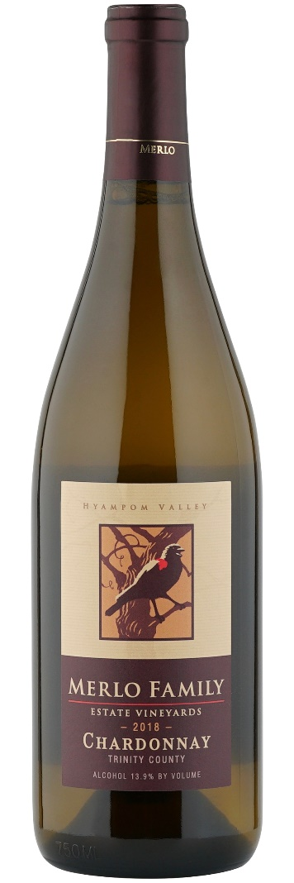
Vineyards:
The Merlo Family Vineyards are located on the riverbanks of the wild and scenic South Fork of the Trinity River. Surrounded by 8000 ft. mountains on all sides, the vineyards are higher than most California vineyards, at an elevation of 1,250 feet. The valley floor has alluvial soils, allowing for excellent drainage and producing elegant yet complex flavors. The surrounding hillsides are composed of shallow native clay, which helps to create bold, well- structured wines. The growing season, a full three to four weeks later than that of Napa or Sonoma, allows for a much slower ripening, increasing hang time and creating full concentrated flavors without over ripening or depleting natural acids.

Tasting Notes:
The wine displays a light golden straw color and brilliant clarity. The aromatics of honeydew and apple mingle with a hint of baking spices while retaining a sense of freshness. On the palate the wine is full and creamy, but not overtly buttery. Slight vanilla and toast from the oak are there, but they are discreet and well integrated in the wine serving a supporting rather than leading role. The pallet is clean with subtle citrus and mineral notes. The wine is balanced with a clean finish.
Enology:
Composition: 100% Chardonnay
Aging: 80% Neutral Oak 20% New French Oak
pH: 3.6
TA: 5.8 Gr/Lt.
ALC: 13.8%
Production: 820 cases Release: Feb 2022

